 | JACKSON HOLE AIRPORT STAFF UPDATE
December 2021-January 2022
In This Issue  - Employee of the Month  - Welcome New Staff Members  - Community Outreach  - GTNP Report  - GFOA Certificate of Achievement  - Capital Plan Update  - Southern Departure Task Force  - Employee Recognition  - COVID Precautions  - Parking Lot Safety | Picture of the Month  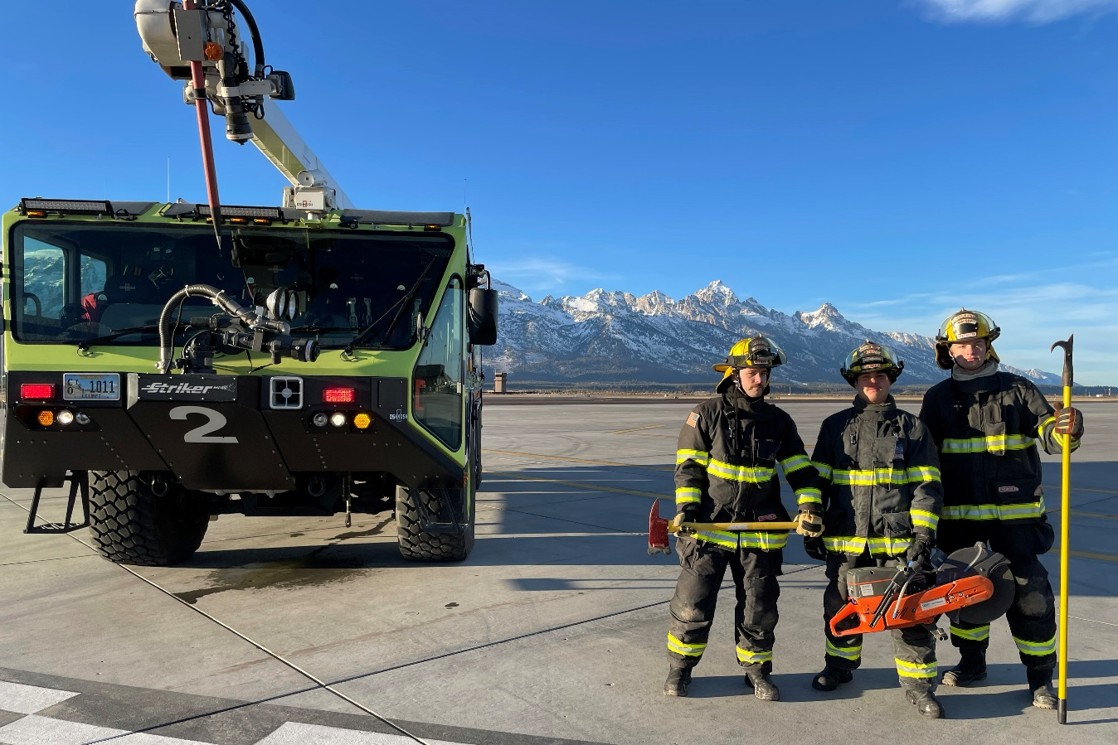Submit your photo entries to Kevin Dunnigan each month with a short description to be considered for Picture of the Month.  Employee of the Month  Kevin Dunnigan, Communications Assistant, received the December Employee of the Month Award. Kevin just recently joined the JAC team, and he was nominated for his work creating the new Careers section of the airport’s website. He was given the task as a concept and was able to stand up the new jobs portal quickly. The new page meets the airport’s human resources goals and is designed to attract and inform candidates. Congratulations, Kevin!  Welcome New Staff Members  Brandt Bennett, Operations, is an Army veteran currently pursuing degrees in Aviation Safety and Operations, Airport Management, and Chinese Studies from the University of North Dakota. He previously interned at the Northern Plains UAS Test Site and loves wildlife photography.  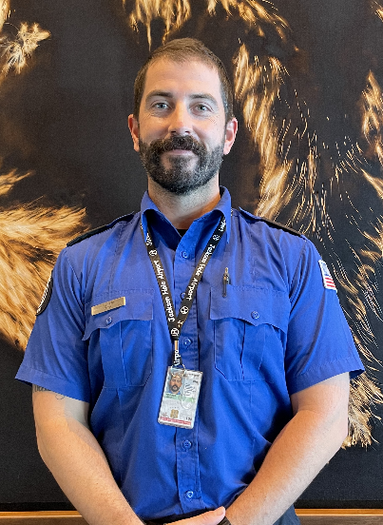  Jason Younker, Transportation Security Officer, was born and raised in the Pacific Northwest. He earned a master's degree in 2013 and has worked throughout the western U.S. for the past several years. After getting married in 2019, Jason and his wife settled in Eastern Idaho, where they can enjoy the mountains while remaining close to family. He is excited to begin a career with the Jackson Hole Airport.  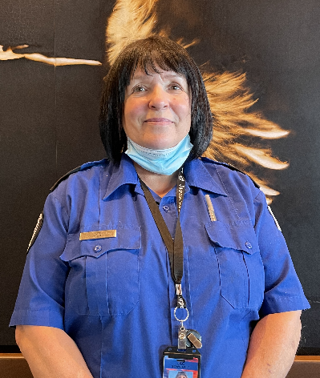  Rhonda Foye, Transportation Security Officer, is originally from Seattle, WA and moved to Gettysburg, PA when she was 19. She raised her 3 children in Gettysburg and then moved back to Seattle once her children were all away at school. She met her husband while working at Home Depot as a kitchen designer. After living on Vashon Island for 20 years, they moved to Idaho 3 years ago. She has been with the airport for 6 months and really enjoys her job!  Community Outreach  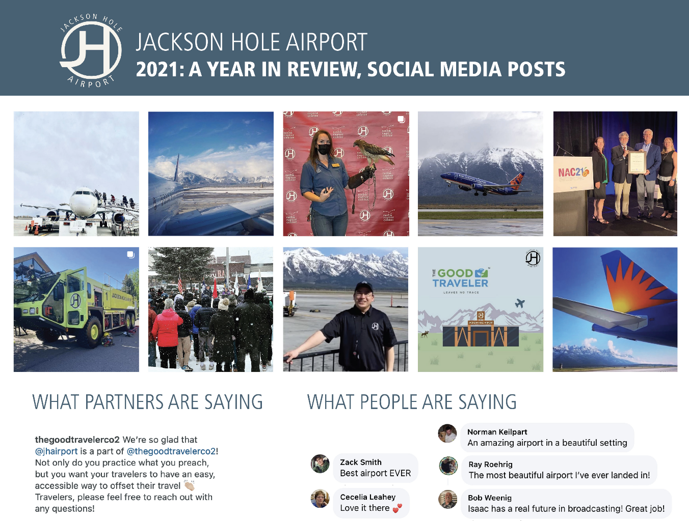  At the December board meeting, the Communications team shared the above review to showcase some of the social media activity over the past year. As a reminder, the airport is active on the following platforms:  Facebook: @jhairport  Instagram: @jhairport  Twitter: @jhairport  Stay in the know and help spread the word using the website’s Projects landing page. This section of the site includes a variety of efforts that will help keep the public updated about the status of projects and reconstruction progress.  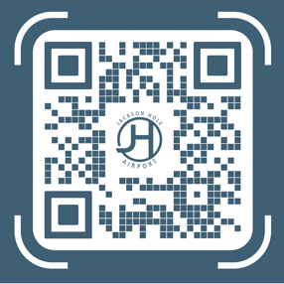  To view project information,  please scan the QR code:  GTNP Report  As winter arrives, the Park will begin grooming the Teton Park roads to provide great cross country skiing opportunities for visitors and locals. One of the Park’s top winter priorities is ensuring that the roadways, especially the highway to the airport, is cleared in a timely fashion. The Park is also looking at adding additional lighting to the Gros Ventre Roundabout to increase safety.  Grizzly 399 and her brood are finally in hibernation for the winter. The Park is working with partners to inform backcountry skiers how they can take advantage of the Park’s offerings while respecting the big horn sheep population.  After a five-year absence, the National Park Service has a new Director. Chuck Sams was recently confirmed by the Senate, and he and his wife have ties to the Grand Tetons.  Accounting Team Receives  GFOA Certificate of Excellence  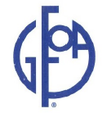  The Government Finance Officers Association of the United States (GFOA) has awarded the Certificate of Achievement for Excellence in Financial Reporting to the Airport’s accounting department for its annual comprehensive financial report for the 2020 fiscal year.  The Certificate of Achievement is the highest form of recognition in the area of governmental accounting and financial reporting, and its attainment represents a significant accomplishment by a government and its management. In addition, when a Certificate of Achievement is awarded to a government, an Award of Financial Reporting Achievement (AFRA) is also presented to the department that is primarily responsible for its having earned the Certificate.  Capital Plan Update  The TSA checkpoint remodel will be underway starting Jan 3rd in the terminal. The security screening checkpoint is the oldest part of the terminal building at JAC. To accommodate new security screening technology, the checkpoint will be undergoing a complete remodel and expansion. The checkpoint project is expected to be completed by June 27th and will coincide with the runway re-opening on June 28th, 2022.  From mid-January through April, travelers will be using a temporary security checkpoint equipped with three screening lanes until the runway closure begins. The lines for the temporary screening lanes will extend out towards the rental car desks. To help mitigate congestion during peak travel times in the area between the temporary screening lanes and the rental car desks, Staff is advising customers to exit the baggage claim area to the far right near the bathrooms.  Upon completion, travelers can expect to experience a spacious checkpoint with four active screening lanes.  Southern Departure Task Force  The newly formed Southern Departure Task Force is set to hold their first meeting Thursday, February 10th. Airport Board member Valerie Brown is slated to chair the effort. The Bridger-Teton National Forest Service, the Grand Teton National Park, and the National Elk Refuge will have representation. In addition, the group will include a member of ANPAC and a local pilot.  Assembling a Task Force is the first phase in a three phase process aimed at studying southern departure procedures. The Task Force will analyze existing departure procedures, review what the FAA had previously produced in KICNE ONE and better understand its effects, and to look at other future departures and their prospective paths.  Employee Recognition  The entire Airport staff and the rest of the Airport Board would like to take a moment to extend sincere appreciation to Jerry Blann for his 23 years of service to the Airport Board. His dedication and commitment serving the Airport, the community, and the State of Wyoming is unparalleled.  The Airport has completed numerous capital projects under Jerry’s guidance and direction. He has played a central role in the successes of the Airport as a partner with the National Park Service, an environmental steward, and an industry leader. Additionally, his contributions to JHAIR, the Wyoming Aeronautics Commission, and promoting tourism across the State, further exemplify his dedication.  The decisions made by the Airport Board over the years have been thoughtful and their impacts have been long lasting and aimed at ensuring the airport is best positioned to service the community into the future. JHAIR has created a unique collaboration between the organization, the airlines, and the Airport. This relationship, built on understanding and finding common ground, is unlike anything else in the country.  Jerry’s thoughtfulness, creativity, and ability to create consensus are skills that served the Board well and will be greatly missed. The Airport has benefited greatly from his service. Thank you Jerry!  Parking Lot Safety  With winter in full swing at the airport, please remember to be safe when navigating the parking lot. It’s important to wear shoes or boots that will get you in and out of the parking lot safely if there is snow or ice.  Keep in mind that snow removal is an ongoing and tedious task for our operations staff. When you are entering or exiting the parking lot, be cautious when approaching a snow removal vehicle and yield to them when necessary.

