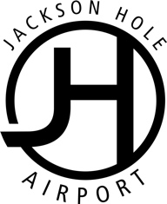

FOR IMMEDIATE RELEASE
October 31, 2019

Jackson Hole Airport Awarded Large Business of the Year
Jackson Hole Chamber of Commerce Recognized the Airport for a Significant Year

Jackson, Wyoming – The Jackson Hole Airport was awarded the Jackson Hole Chamber of Commerce’s Large Business of the Year Award on Friday evening, October 25th, at the Million Dollar Cowboy Bar.

Jackson Hole Chamber of Commerce recognized individuals and businesses in the community that contributed leadership and vision in 2019 and made a lasting impact on Jackson Hole.

The Large Business of the Year Award recognized the JH Airport for its achievements in excellence in all areas of operations and contributions to the Jackson community.

The Jackson Hole Airport and the Airport Board have taken significant steps to be leaders in the community in environmental stewardship and providing exceptional customer service to locals and visitors traveling through the Airport.

Some of their accomplishments this year have included a commitment to 100% Green Energy through Energy Conservation Works; receiving BEST Certification through the River Wind Foundation; completion of a stormwater filtration system; providing a great place to work with an established culture of support and continuing education; and being recognized as the Best Tiny Airport in the world by Fodor’s.

“We are honored to be acknowledged by our community and the JH Chamber of Commerce as the Large Business of the Year,” says Jackson Hole Airport Board President Rick Braun. “Our dedication to the community, its people and ecosystem will be our focus as we continue to set the bar higher.”
####

